|  |  |
| --- | --- |
| **Departmental Use Only** | |
| **Revision No: 05** | **Unit:**  BF#3 |
| **Revision Date:** 12.04.2022 | **Dept.:**  Mech |

**FORMAT FOR HAZARD IDENTIFICATION**

A. Work activity information

|  |  |  |
| --- | --- | --- |
| Sr.No. | Details | Remark |
| 1) | Task being carried out, their duration and Frequency: | Maintenance of Hot Blast Stoves.  2-36 hrs  Monthly |
| 2) | Location (s) where the work is carried out. | Hot Blast Stoves of BF3 |
| 3) | Who normally/occasionally carried out the task | Engineer in charge  Workmen on job |
| 4) | Who else may be affected by the work (For example visitors, subcontractors, the public) | Contractor workmen  Production/Electrical/Instrumentation Engineers. |
| 5) | a)Has the personnel trained for performing the task  b) Any special training required | Yes  Hoist operation |
| 6) | Is the written system of work mandatory? If yes state the procedure no. | WI/BF3/15 |
| 7) | Is the work permit required for the task | Yes |
| 8) | Plant and machinery that may be used:  Eg : crusher, conveyor, crane, heavy earthing equipment, Truck etc, | Crane, truck, hydra, hoist, chain pulley block, etc |
| 9) | Any electrically operated hand tools are used | Yes |
| 10) | Manufacturer?s or supplier?s instructions for operation and maintenance plant machinery and powered hand tools are available or not: | No |
| 11) | Chain block, tools and shackles such as wire rope, hydraulic jack etc are used. | Yes |
| 12) | What materials are handled? Size, shape, surface character and weight of materials that may be handled: | Steel Structures, refractory items etc  Irregular  Approx. 5000 kg max |
| 13) | Is the material is required to be moved by hand. If yes Distance and heights of the place where materials have to move by hand. | 25 kg by hand (tools & tackles, small structures)  5 Mt height approximately max |
| 14) | Services used Eg: compressed air, oxygen, acetylene,  LPG gas, hydraulic oil, welding electrode for welding | Oxygen, Acetylene, LPG, hydraulic oil, welding electrode for welding |
| 15) | Physical form of substances encountered during the work (For example fume, gas, vapor, liquid, dust/powder, solid): | Solid ,Liquis(oil) |
| 16) | Content and recommendations of safety data sheets relating to substances used or encountered:  ( this is applicable in case of chemical material) | Yes |
| 17) | a) Relevant acts, regulations and standards relating to the work being done, the plant and machinery used and the materials used or encountered:  b) Is the activity is reviewed for compliance to statutory requirement | Factory Act 1948 and Goa Factory rules 1985-SRR/16  Yes |
| 18) | What is the data (s) required to be monitored during the activity and the frequency of monitoring. | NA |
| 19) | Any information available from within and outside the organization on incident, accident and ill health experience associated with the work being done, equipment and substances used: | 1. On 22.06.2015 at around 19:00 hrs Mr. Ram Bahale Chavan MCK Welder involved in HBS 1 burner valve bottom bolt tightening while coming out from burner valve area was affected by CO gas. The person was shifted to GMC for further treatment and he was discharged on 23.06.2015 morning after overnight observation in the hospital and resume duty. |

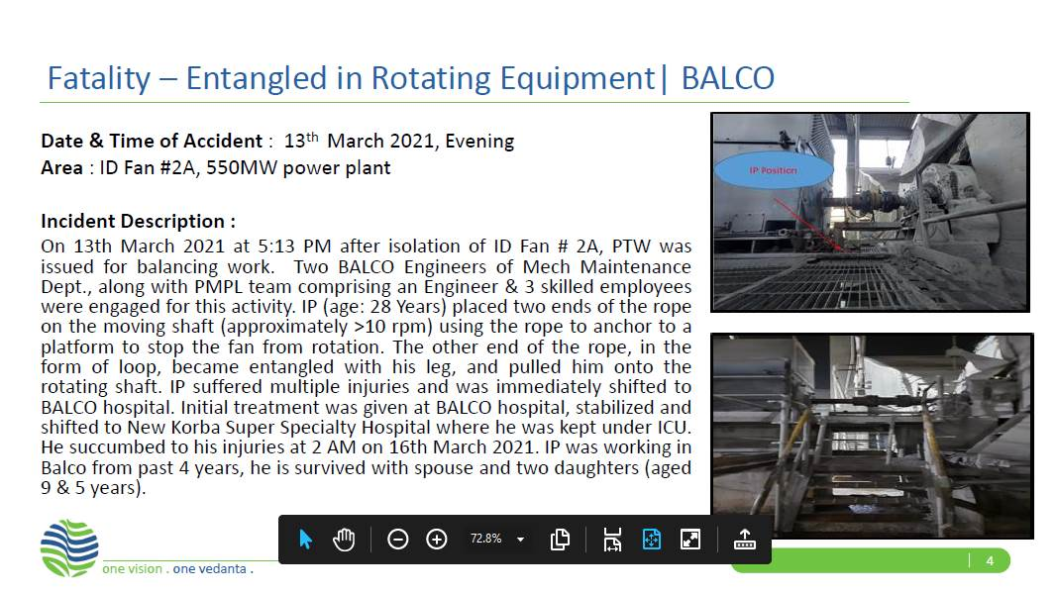

2. From the above activity information hazards are to be identified and recorded below using Appendix 'A' of SP/41

**HAZARDS IDENTIFIED**

**Physical Hazard**

• Pressure, temperature.

• Explosion in accumulators**.**

• Explosion inside stove while doing cutting/welding activity.

• Slip and fall due to oil leakage.

• Itching while handling of glass wool.

**Mechanical Hazard**

• Trapping between two objects,

• Fall of material, hammer, tools, slinged items, bolts, wedges etc.

• Failure of lifting equipments like chain pulley block, sling, D-shackle etc.

• Fall of person from platform, height

• Entanglement

• Impact of moving / slinged items.

• Non usage of PPE’s while carrying out the activity.

• Snapping of hoist wire rope.

**Electrical hazard**

• Shock

**Chemical hazard**

• Co gas poisoning & Fire

**Biological Hazard**

• Bee sting

**Behavioral hazard**

• Alcoholism

• Non usage of PPE’s

• Casual approach while working

|  |  |
| --- | --- |
| **Prepared By:**  **Site Engineer** | **Reviewed By:**  **Mech. Maint. HOD PID2** |
| **Signature:** | **Signature:** |
| **Review Date:03.01.2023** | **Review Date:03.01.2023** |